**MongoDB Case Study – 2**

**Name: PRIYESHWAR  
Mail:** [**priyesh2664@gmail.com**](mailto:priyesh2664@gmail.com)

**Find all the topics and tasks which are thought in the month of October**

db.topics.aggregate([

{$lookup: {

from: "tasks",

localField: "task_id", // field in `topics`

foreignField: "task_id", // field in `tasks`

as: "task_info"

}},

{$match: {

$or: [

{ start_date: { $gte: ISODate("2023-10-01"), $lte: ISODate("2023-10-31") } },

{ "task_info.deadline_date": { $gte: ISODate("2023-10-01"), $lte: ISODate("2023-10-31") } }

]}}]);

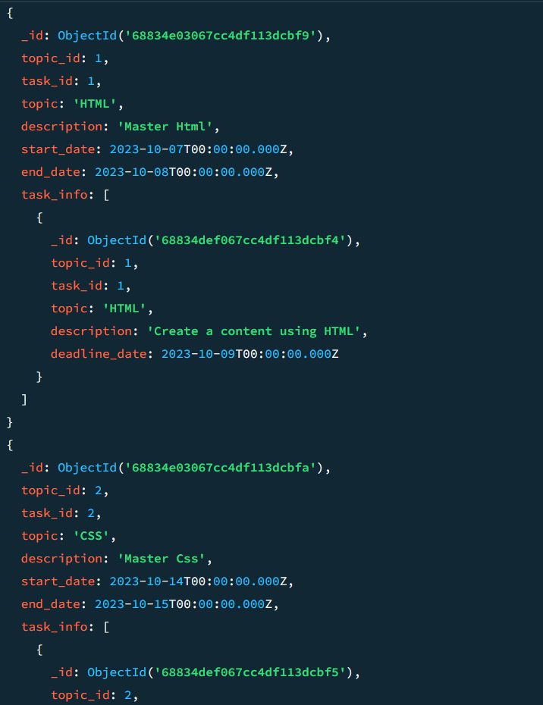

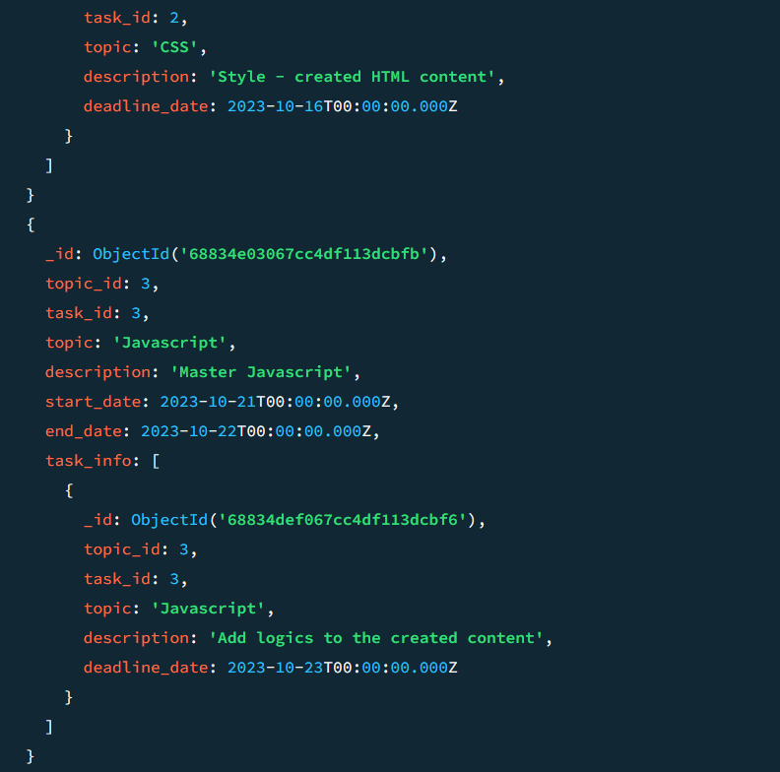

**Find all the company drives which appeared between 15 oct-2023 and 31-oct-2023**

db.companydrives.find({drive_date:{$gte:ISODate("2023-10-15"),$lte:ISODate("2023-10-31")}})

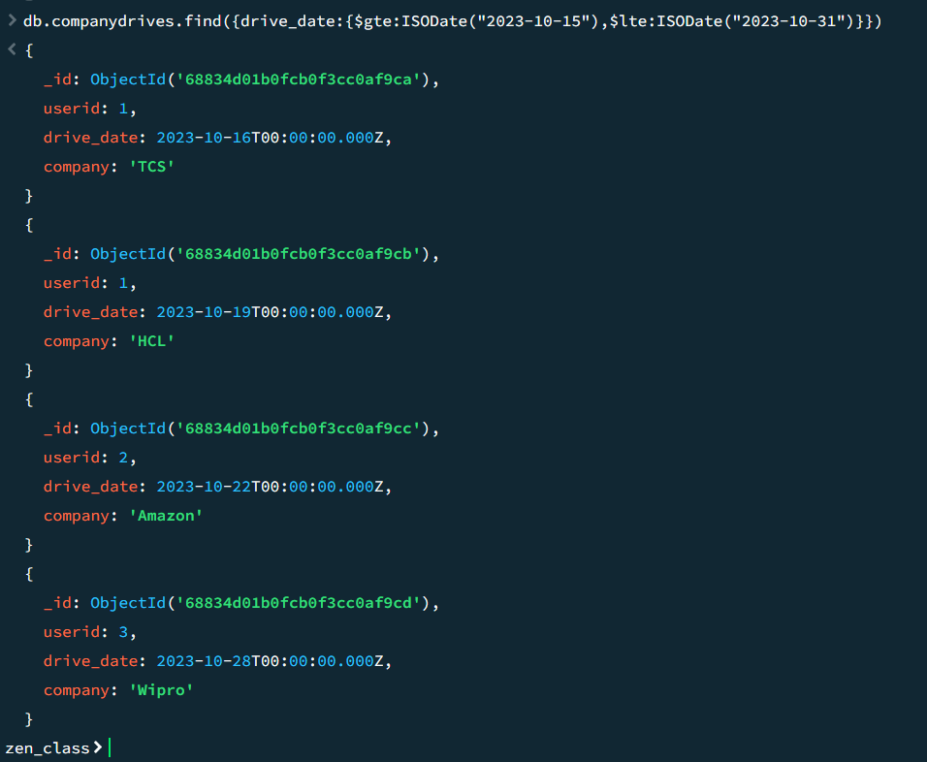

**3.Find the number of problems solved by the user in codekata**

db.codekata.find({},{user_id:1,codekata_solved:1,_id:0})

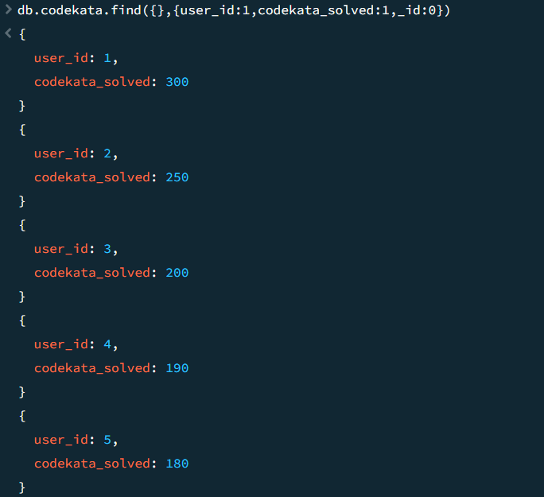

**4.Find all the mentors with who has the mentee's count more than 15**

**db.mentors.find({mentees:{$gt:15}},{_id:0})**

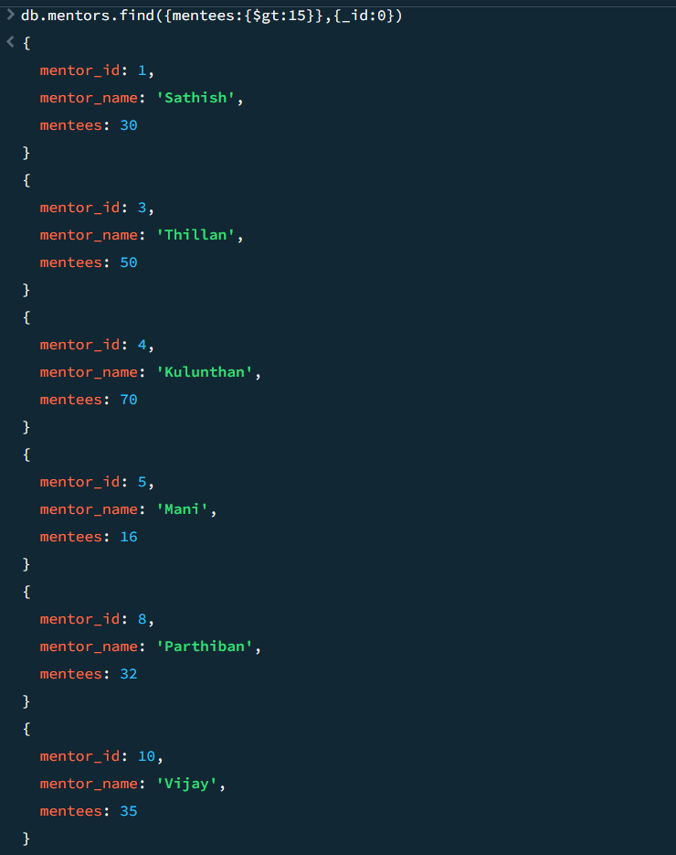

**5.Find the number of users who are absent and task is not submitted between 15 oct-2023 and 31-oct-2023**

db.attendance.aggregate([

{

$match: {

Class_date: {

$gte: ISODate("2023-10-15"),

$lte: ISODate("2023-10-31")

},

attendance: false

}

},

{

$lookup: {

from: "task_completion",

localField: "userid",

foreignField: "userid",

as: "task_info"

}

},

{

$unwind: "$task_info"

},

{

$match: {

"task_info.task_completion": false

}

},

{

$group: {

_id: "$userid"

}

},

{

$count: "absent_and_task_not_completed"

}

])

